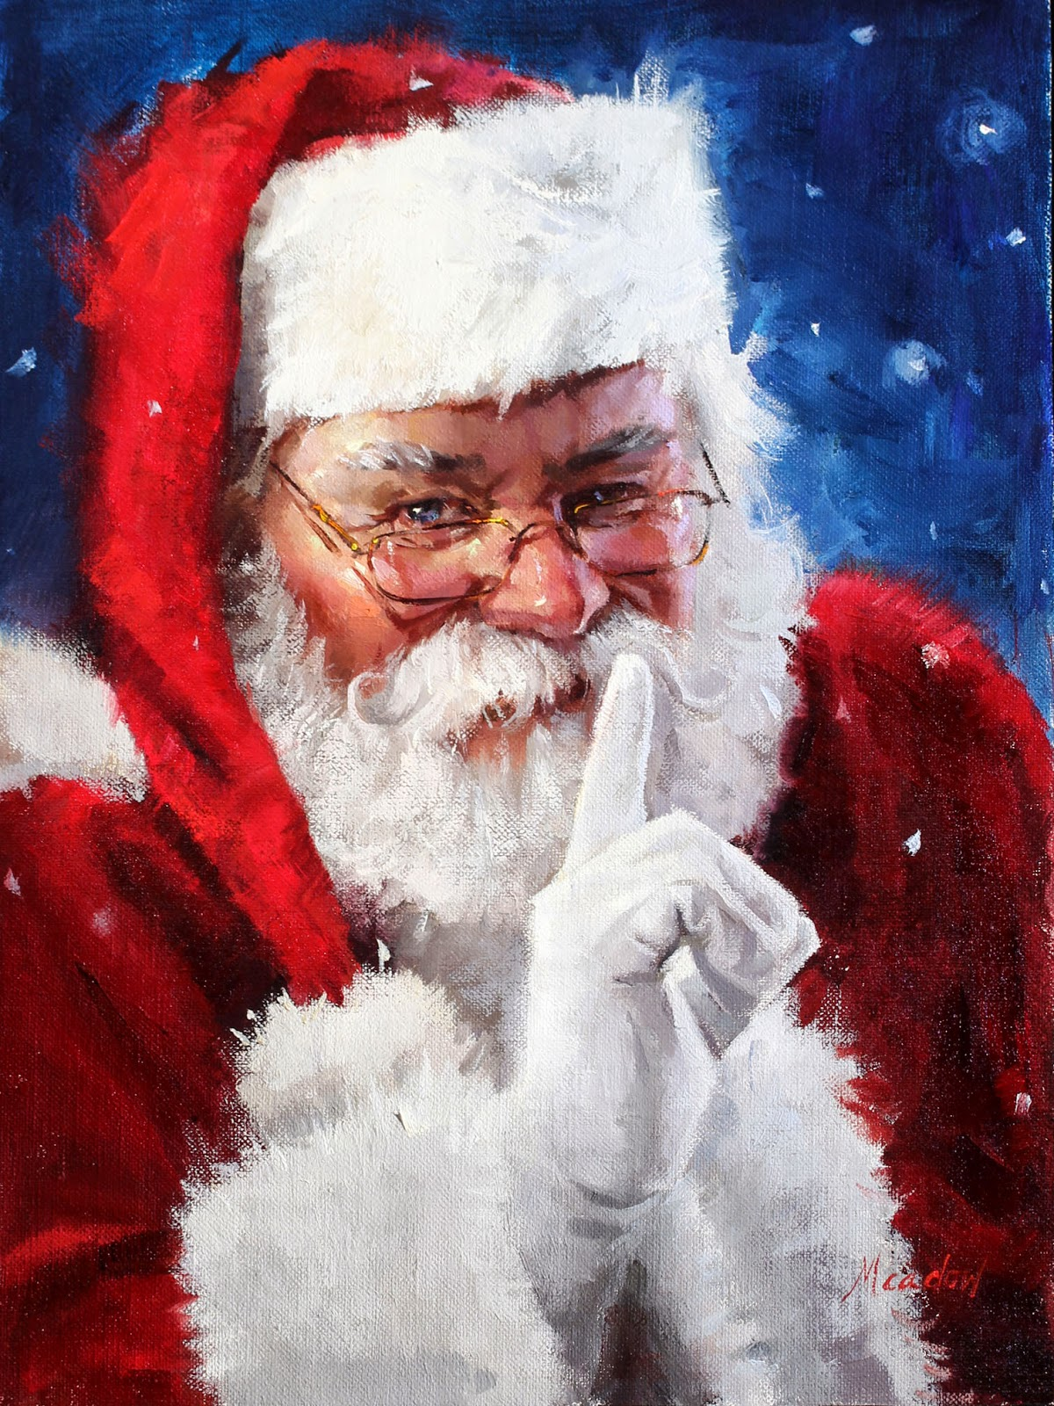

Dear ~~Peter~~,

I am sending you this letter to let you know that as of right now you are on the **NAUGHTY** list.



You have 10 days to straighten up and behave to try to get back to the **NICE** list.

This means that no more ~~smacking your sister, or talking back to your parents, you also need to clean your room.~~

I will be watching and getting ~~reports from your parents, as well as I have access to the cameras of your house.~~

I’m watching,

Santa Claus

**@WWW.CLICK-ME.TODAY**